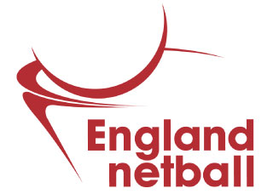

Please follow this essential step-by-step guide to process an England Netball membership for your junior athlete.

(Step 1) Create an Engage account
ENgage is a self-service platform that enables individuals to purchase membership. As you are setting up an account on behalf of a minor, you are required to create an account for yourself, too. This allows you to have more control over your child’s payments as yours and your child’s accounts will be linked together, you are able to purchase their club memberships through your own profile. This does not mean you will be required to purchase a membership for yourself if you do not need one.
- To start, please visit https://engage.englandnetball.co.uk
- Select ‘Create Account’ underneath the login box
- In order to create an account for yourself, select ‘1 adult’ and ‘1 Child’ in the drop-down menus
- Enter your title, name, email address, date of birth, gender, ethnic origin and postcode
- Press the icon to search for your home address (If your address can not be found, please manually enter your address into the fields)
- Enter your mobile and/or home phone number
- Select ‘Next’
- Enter your emergency contact details, including their name, tel number, email address and their relationship to you
- Enter any medical details in the required field (If this does not apply, please enter ‘N/A’
- Tick the Cookie policy and the ENgage terms and conditions boxes, to accept our user agreements
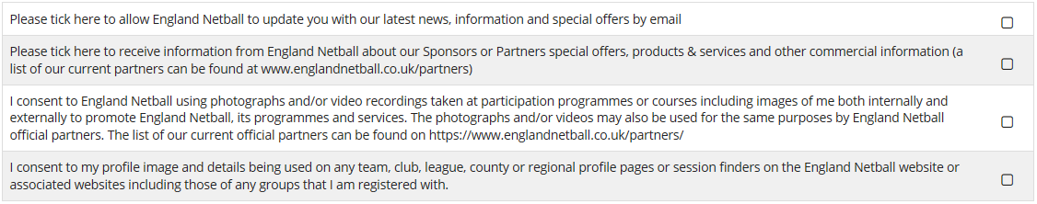
- If you would like to receive updates, news and offers from England Netball, make sure the first box is selected

- Select ‘Next’ to proceed to the next page.
- If you hold any health conditions, please click the appropriate boxes (If you do not wish to disclose this information, please select ‘prefer not to say’ for each question)
- Select ‘Confirm’
- If you are the child’s emergency contact, click the first tick box
- Select their relationship to you, from the drop-down list
- To add an emergency contact for the child, that is not you, please click the tick box and enter the requested fields
- Enter any medical details in the required field (If this does not apply, please enter ‘N/A’
- Enter your child’s title, name, date of birth, gender and ethnic origin
- If the child’s address differs to yours, please manually change the details
- Click ‘Next’
- If your child holds any health conditions, please click the appropriate boxes (If you do not wish to disclose this information about your child, please select ‘prefer not to say’ for each question)
- Select ‘Confirm’
- Once you can confirm that the information displayed is correct, press ‘Confirm’
The details of your account, including your ENA ID and a password reset will be emailed to you from noreply@first-sports.com. Please monitor your junk folder, if the link is not in your inbox as the password re-set link is only valid for 24 hours.
Please make a note of your ENA ID and password, as you will need to enter these credentials each time you wish to log in to ENgage.

(Step 2) Link to a club
Both accounts will need to join the club directory. Please log in to your child’s and your account and complete these instructions,
- Click on the ‘Directory’ button
- Click on the funnel symbol on the right hand-side of the screen
- Select the ‘+’ symbol
- Select ‘Reference’
- Enter the club ID (Please contact your club if you’re unsure what this is)
- Click ‘Apply’
- Select the small circle to the left of the club name
- Click ‘Join’
- Select from individual type dropdown, as appropriate
- Select ‘Save’

(Step 3) Purchase membership
You will then need to contact your child’s club directly to find out how they plan to release the membership packages and when.
If the club responds that the packages are not available for public purchase, this means that they will process membership packages and send payment requests directly by email.
However, if the club responds that the packages are available for public purchase, please follow these instructions,
- Log into your Engage account
- Select the ‘Buy membership at {netball club}’ button
- Select your child’s name
- Click the ‘U11/U14/U18 membership package’
- Select ‘Checkout’
- Click the circle next to the wanted payment method
- Select ‘Pay now’
- Enter your payment details

(Step 4) 2nd claim (if required)
If your child wishes to play for 2 or more clubs, you will need to simply repeat the guidance in points 2 and 3, for each club.
Please note, as you will have already paid the England Netball fee, this fee, along with any duplicate county and regional fees (that were settled through the 1st claim order), will be deducted from the preceding order/s and you will only be charged the difference.

