Please follow this essential step-by-step guide to process an England Netball membership.

(Step 1) Create an Engage account
ENgage is a self-service platform, which means each individual is required to make their own account.
- To start, please visit https://engage.englandnetball.co.uk
- Select ‘Create Account’ underneath the login box
- In order to create an account for yourself, select ‘1 adult’ in the drop-down menu
- Enter your title, name, email address, date of birth, gender, ethnic origin and postcode
- Press the icon to search for your home address (If your address can not be found, please manually enter your address into the fields)
- Enter your mobile and/or home phone number
- Select ‘Next’
- Enter your emergency contact details, including their name, tel number, email address and their relationship to you
- Enter any medical details in the required field (If this does not apply, please enter ‘N/A’
- Tick the Cookie policy and the ENgage terms and conditions boxes, to accept our user agreements
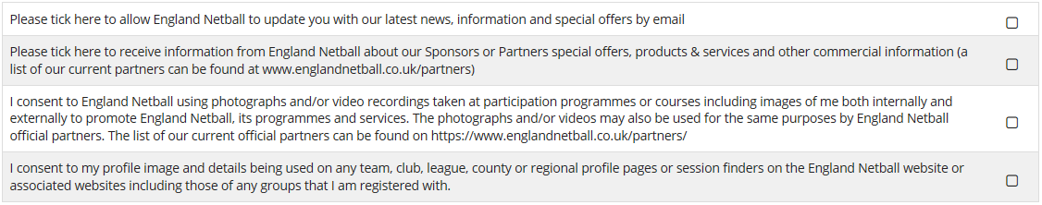
- If you would like to receive updates, news and offers from England Netball, make sure the first box is selected

- Select ‘Next’ to proceed to the next page.
- If you hold any health conditions, please click the appropriate boxes (If you do not wish to disclose this information, please select ‘prefer not to say’ for each question)
- Select ‘Confirm’
- Once you can confirm that the information displayed is correct, press ‘Confirm’
The details of your account, including your ENA ID and a password reset will be emailed to you from noreply@first-sports.com. Please monitor your junk folder, if the link is not in your inbox as the password re-set link is only valid for 24 hours.
Please make a note of your ENA ID and password, as you will need to enter these credentials each time you wish to log in to ENgage.

(Step 3) Purchase membership
To purchase a membership, please follow these instructions,
- Log into your Engage account
- Select the ‘Buy membership at England Netball’ button
- Click the ‘U14/U18/O18 membership package’
- Select ‘Checkout’
- Click the circle next to the wanted payment method
- Select ‘Pay now’
- Enter your payment details

