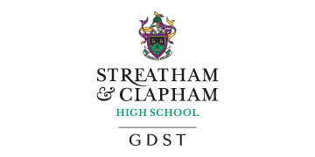

Graduate Sports Fellow (Netball)

Salary: £20,313 pa (full time equivalent) / £11,336 pa (actual salary)
Hours: Part time
Contract: Permanent
Required for September 2021

This is an outstanding opportunity for a dynamic and innovative Sports Science graduate or netball specialist to play a key role supporting the growing Physical Education department at Streatham & Clapham High School.

This is a newly created position and your key responsibilities will include:

- Contributing to the co-curricular sporting life of Streatham & Clapham High School
- Assisting with the smooth running of the PE department
- Accompanying teams to fixtures and tours outside of normal school hours
- Supporting students in their preparation for practical and PE theory exams
- Supporting students in their preparation for university and Sport Science college applications
- Assisting in the planning and delivery of tournaments hosted by the School

You will be joining a Physical Education department which celebrates the sporting ability of all pupils and provides opportunities for pupils to experience a range of sports. We have excellent facilities for sport, including three outside netball courts.

To be considered for this role, you will need to be a well qualified graduate in Sport Science or have at least a Level 1 coaching qualification in Netball. Experience of playing in a team is equally important.

Why work at Streatham & Clapham High School

Streatham & Clapham High School is a vibrant, exciting and fulfilling place in which to work.
All members of staff benefit from a highly regarded central training and personal development programme and access to a GDST-wide virtual learning environment that gives opportunity for discussion and exchange of information with colleagues in other Trust schools. Staff are also entitled to an interest-free season ticket loan, reduced BUPA subscription, and free lunches during term time.

For further details and to apply please click here: https://my.corehr.com/pls/gdstrecruit/erq_jobspec_version_4.jobspec?p_id=008385

The closing date for applications is no later than noon on Friday 21st May 2021.

Interviews will take place week commencing 24th of May 2021, though the school reserves the right to appoint an exceptional candidate at any stage of the application process.

The GDST is committed to diversity, inclusion and real change: a family where every individual is valued, respected and included.

We are committed to the safeguarding of children and child protection screening will apply to this post.

