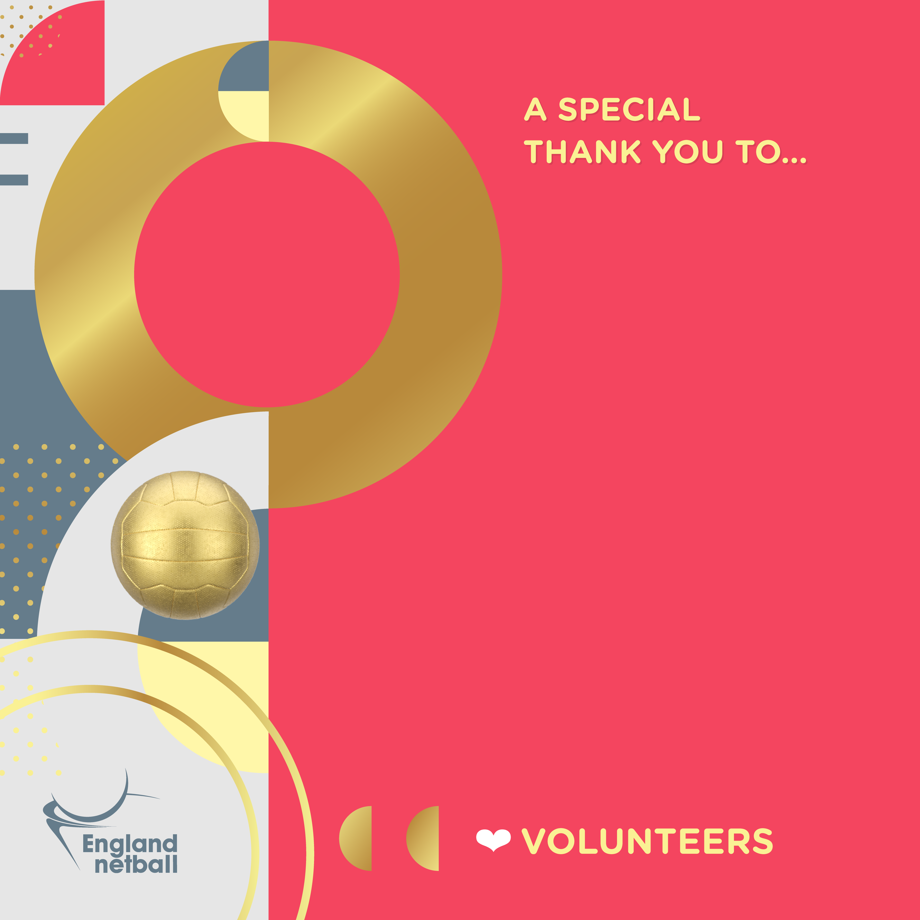



**Name of volunteer**

Role

**Your Name**  
Role, Organisation

Your text here should contain a maximum of 43 words. Your text here should contain a maximum of 43 word. Your text here should contain a maximum of 43 word. Your text here should contain a maximum of 43 word. Your text here.

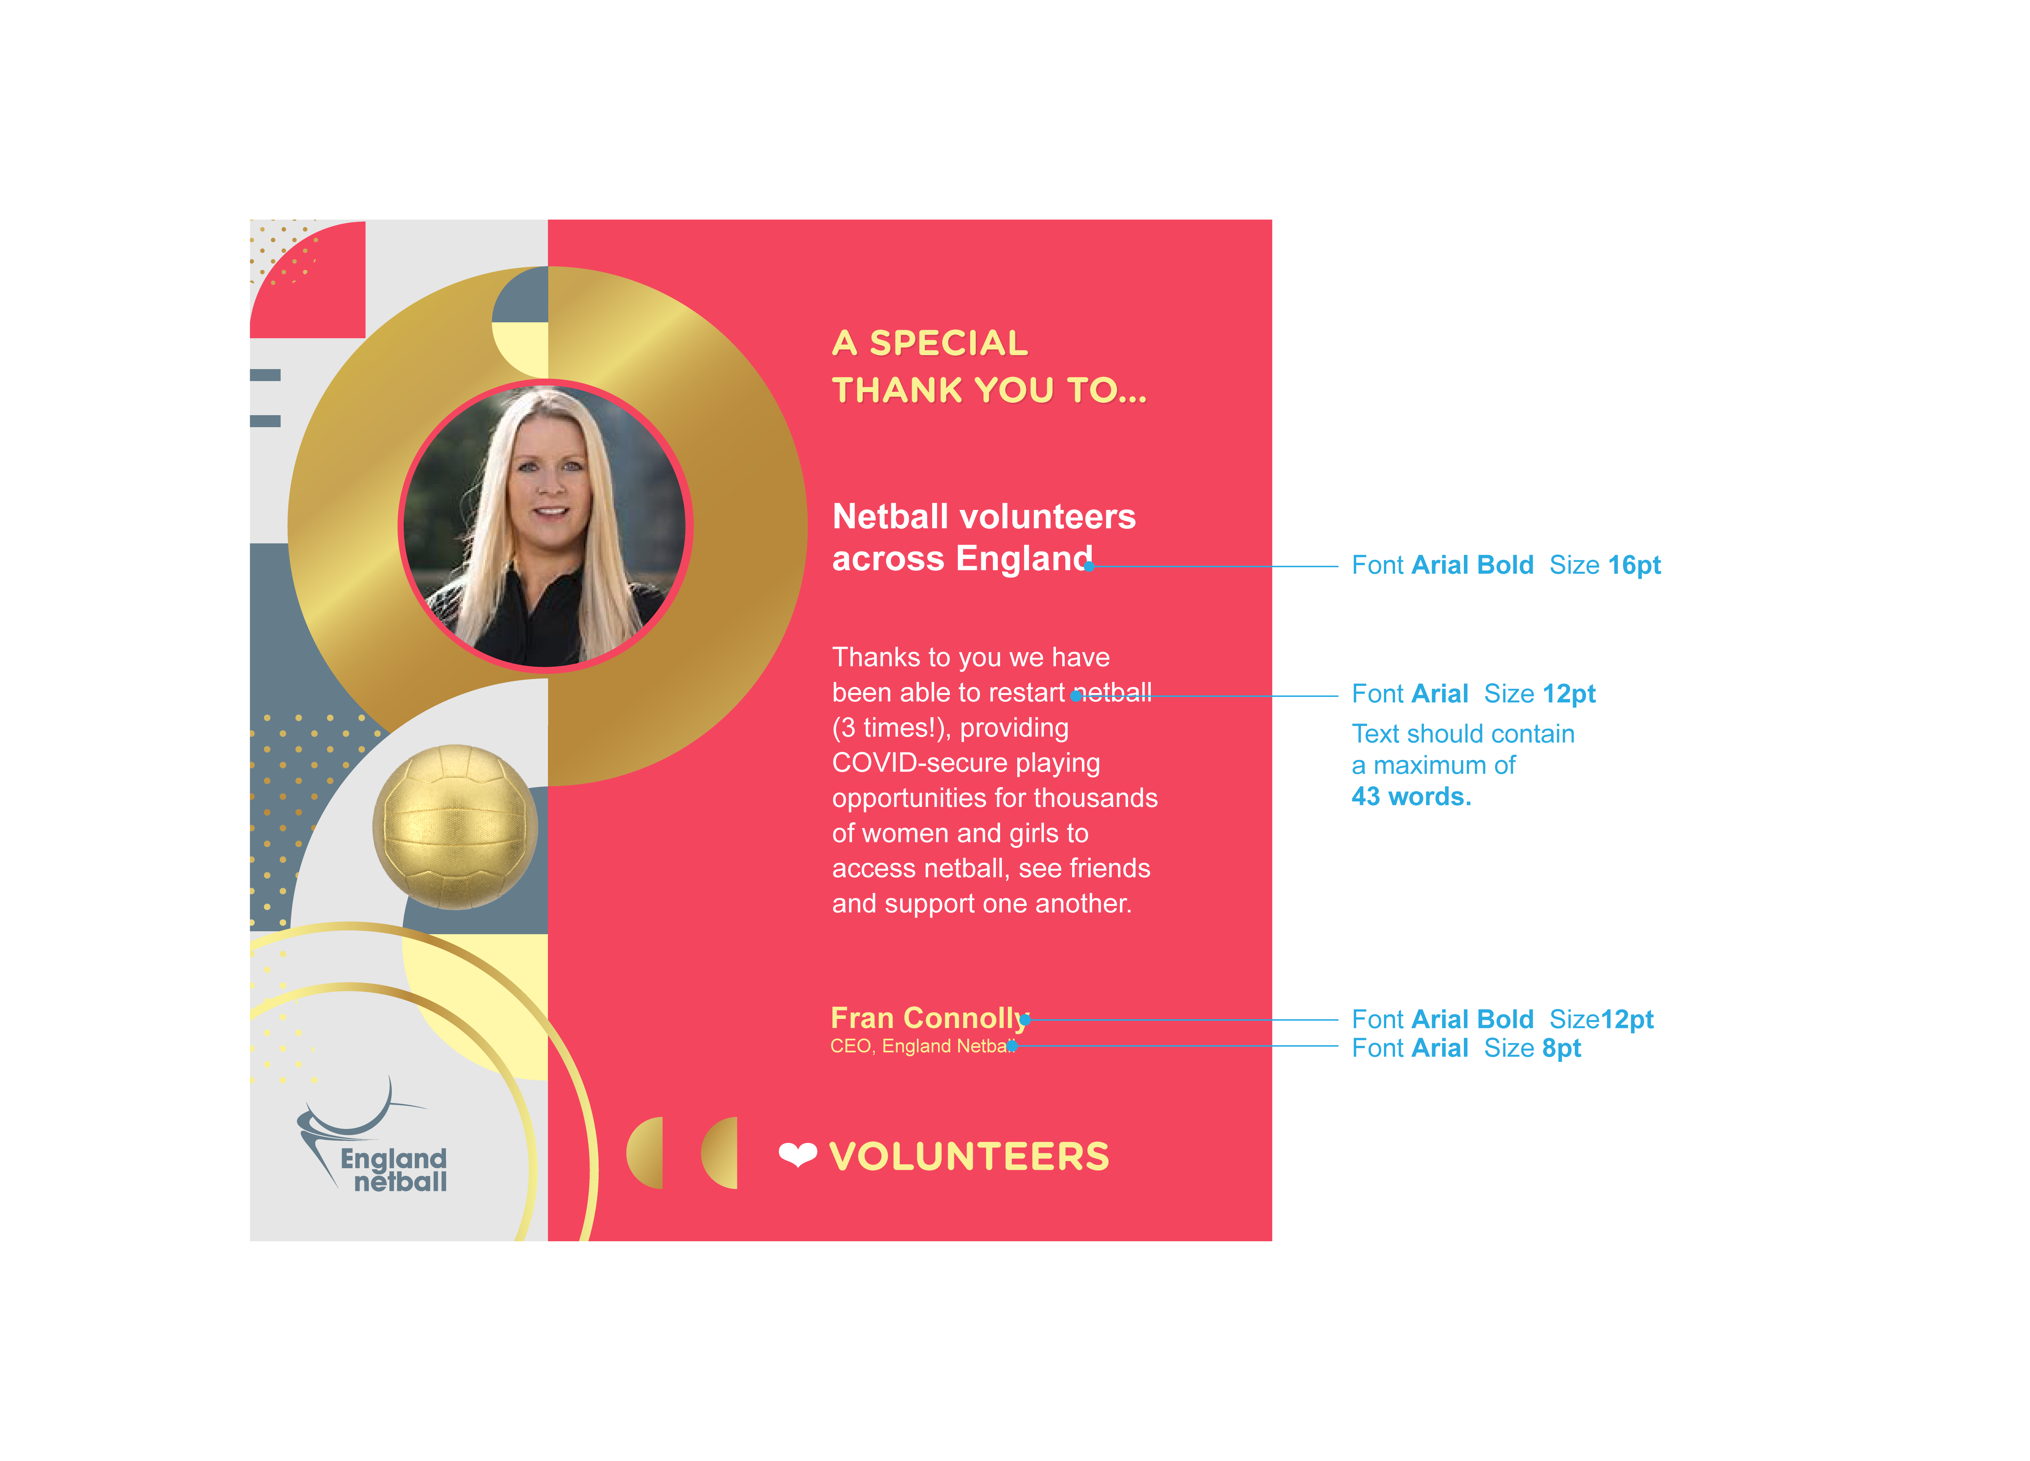

EXAMPLE