About the Competition tool

Individuals with relevant roles within a Region, County and League will be provided with access to the full competition management functionality, in order to administer competitions.
Club committee are able to access matches that they are part of through the ‘Team management’ section of the system, if your league(s) choose to use the online functionality. However, this will be restricted to the ‘Match Card’ feature, to allow you to enter details such as team line ups and scores for fixture.
If you, as a club arrange friendly fixtures, there is a function in the ‘Team management’ section to administer and record these.

Club Administration of Match Details
Rather than the league committee administering the results of the match within the competition tool, the teams themselves can complete this information, therefore reducing the administration required by the league.
If a competition has been published, the clubs competing will be able to access matches they are involved in. This can be done by anyone with access to the Team management section of Engage:
- Chairperson
- Secretary
- Safeguarding Officer
- Vice Chair
- Performance Lead
- Lead/Head Coach
- Assistant Coach
- Team Manager

Please follow this guidance if you hold one of these club roles:
- Log into ENgage
- In the My Organisations box, select the thumbnail next to your club name
- In the 3x3 grid of squares in the top left select Team Management
- Select the team you want to administer a match for in the Last Result or the Next Fixture sections of the dashboard (If the team you are looking for is not in the list on the dashboard, select the arrow to see the full list of matches available to administer)
Once you have selected the team, you will be presented with a table of all the matches relating to the team
- Click on the funnel symbol on the right hand-side of the screen, to find the relevant match
- Select the + symbol
- Select Season
- Click the appropriate season from the drop-down list
- Select the + symbol
- Select Date
- Enter the match date in the field
- Click Apply
- Double click on the Date column of the match to go to the Match Card for the Fixture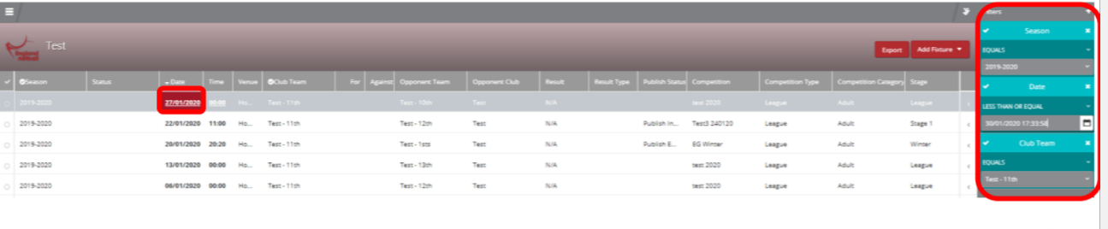
- Depending on what information the competition organiser has set to be collected, details can be entered in the Home Team, Away Team and Post Match tabs

