CASE STUDY: ONLINE LOTTERY FOR CLUBS
EMERALD WARRIORS RFC – May 2020
This case study was presented at the IRFU Webinar:
Online Fundraising Options For Rugby Clubs (21/05/20) and is reproduced with permission.
Irish Rugby would like to thank Emerald Warriors RFC for participating.

Irish Rugby: We're joined by Phillip Purcell from Emerald Warriors. Phillip, you have been involved in setting up an online lottery in your club. Can you explain to us how you went about that?

Emerald Warriors: I’m the Fundraising Officer for our club since last year. I joined the committee and one of my goals was to create a club lottery to raise much needed money for the club and bring the club through all the steps involved with that.

That was everything from getting the lottery licence straight through to launching it at one of our club events in December.

Irish Rugby: Bring us through that process. What's the first thing you do if you want to set up a club lotto? Is it the same if it's offline or online?

Emerald Warriors: The first thing you want to do regardless of whether it's going to be offline or online is to get a charity lottery licence. A charity lottery license enables the club to run the lotto online or offline. The first step involved in that is getting on to a solicitor. They can get the application for the charity lottery licence done through the District Court.

It takes for four weeks to get that licence through the District Court and that is the most time-consuming part of the whole process. Within those four weeks you can set up everything from your graphics to your portal to where you want to run your online lotto.

Irish Rugby: Do you think all rugby clubs are able to apply for that lottery licence?

Emerald Warriors: You don’t have to be a registered charity to get the charity lottery licence - you can be a sports club, philanthropic society or registered charity. Every sports club falls under one of those categories so everyone can make an application to get one of them.

What we did in Emerald Warriors was get one of our sponsors to pay for the lottery licence. If clubs are involved with any sort of an organisation who would be in a position to sponsor that. then it would be a good idea to pursue.

Irish Rugby: Then your solicitor applies to either the District Court for this licence?

Emerald Warriors: They notify the District Court that you're applying for the licence then it's heard four weeks later. 9 times out of 10, unless there's any sort of objection, it can be granted to the club to proceed with the lottery.

Irish Rugby: How did you proceed from there?

Emerald Warriors: We had all our graphics designed up within that four-week period from when we applied to when we got our licence. We let all the members know that there was a club lottery on the way and happening so building up a bit of hype and excitement about that.

Then we also contacted a provider that we use which is Club Force. There are many other providers out there but the one particular provider that we used for our lotto is Club Force. They got everything in order for this to go live and once we had our charity licence it was just a case of hitting ‘live’ and away we go.

Irish Rugby: And do you run this? Do people pay up every week? How much do they charge?

Emerald Warriors: With the online lotto and with the different providers you can choose how much you charge to people. At the moment we only charge €1 in Emerald Warriors but some clubs charge €2 and some clubs charge €3, but for us we just decided to charge €1.

Members can sign up to a minimum of 5 draws online up to a maximum of 52 draws and there's different combinations of how you can go about that. I know some with clubs you can do weekly and some clubs you can only buy 10 draws at a time. It's completely up to the club and what the club thinks would suit itself.

That's a committee decision more so than an individual decision, but for us we allow people to sign up for a minimum of 5 weeks and a maximum of 52.

Irish Rugby: And how has it worked for you so far?

Emerald Warriors: So far so good. We have over 68% of our membership signed up to our online lottery now. It was launched on the 6th of December and up until the start of May this year we brought in €3,500 euro. That was pretty good considering we had a target of €7,000 for the year and we’re ahead of that now.

Irish Rugby: Brilliant, and what sort of charges are there? Apart from obviously paying out the money if somebody wins, what are the charges that you have with Club Force?

Emerald Warriors: So with Club Force fees, they charge us 10% of our lottery sales. That's 10% of every euro that comes in going to Club Force. Some providers charge X amount of a percentage plus a fee for processing, but our agreement with Club Force is 10% of the lottery sales. There are no hidden fees or anything like that.

Then again Club Force were the ones that worked out for us, there are other providers out there that do provide a lot of service that will work for other clubs as well.

Irish Rugby: And Is it technically difficult to put on your website or is that all taken care of by the supplier?

Emerald Warriors: If someone is at all tech savvy in a club, it's a case of adding a widget to the website but the biggest one for us is social media and our club newsletter.

We put it out twice a week on our social media to get those that are just interested in seeing what the club is doing and keeping engaged.

We also send it on a monthly newsletter to every member, so they know where it's at - whether it was won or whether it wasn't won. It’s about keeping it at the front of people's minds, so they tune in to see if there are any results and make sure they are signed up to it.

Irish Rugby: Have you any other last thoughts or any other learnings?

Emerald Warriors: I would say that the club lottery could develop into so much more. At the moment we are only really targeting our members, but in year two of my fundraising plan we have a plan to hit our sponsors and grow it to engage with people’s families and sponsors.

There are opportunities to grow with the club lottery. It’s quite an easily managed system.

+++
If you did not attend the event and would like to register your interest for another webinar on fundraising. email ross.odonoghue@Irfu.ie with details of your club and your fundraising role with that club. If your club has a fundraising case study to share that would be of value to other clubs, please also get in touch.
Reference to specific online platforms in the Webinar: Online Fundraising Options For Clubs or its case studies does not constitute an endorsement by the IRFU. Clubs are encouraged to show due diligence in assessing their online fundraising options and comply with all necessary regulations.
OUR VALUES:
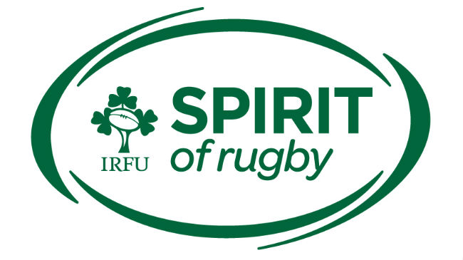

RESPECT | INTEGRITY | INCLUSIVITY | FUN | EXCELLENCE

