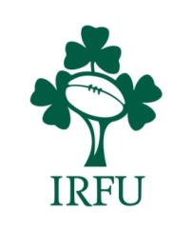

IRFU Performance Coach Course 2023
From 2019 onwards the IRFU Stage 4 Head and Assistant Coaching Course has been replaced by the IRFU Performance Coaching Award.

PLEASE SUBMIT THIS EXPRESSION OF INTEREST TO YOUR LISTED PROVINCIAL CONTACT
Return emails with subject: “Performance Coach Award” before Friday 19th May 2023

DO NOT submit any payment until your place and the course details are confirmed by official invitation

Confirmed dates and course schedule will be communicated upon acceptance to the course, this course will be delivered through a blended approach with both online and in person workshops. The course modules will be delivered through July/August/September 2023. Full course attendance and submission of all course work is required to complete the award.

Your Details - (please ensure any written responses can be clearly read)

Contact Details |  | Coaching Experience
Name |  | Year | Club/School | Team | Coaching Role  (Head / Assistant)
Date of Birth |  | 2023/24
Email address |  | 2022/23
Phone Number |  | 2021/22
 |  | 2020/21

Please submit your expression of interest to the relevant provincial contact below:

Province | Return Email address
Connacht | zoe.langsdale@connachtrugby.ie
Leinster | Declan.obrien@leinsterrugby.ie
Munster | education@munsterrugby.ie
Ulster | budge.pountney@ulsterrugby.com

