Mini 1- Week 2
Sample Session Theme: Return to Rugby
Session Focus – Ball Familiarisation/Catch Pass

ACTIVITY | NOTES
Warm Up Game with Movement Skills  (10 Minutes) | Movement Skills/Game  - Animal Movements  - Relay races  - Piggy in the middle
Game  (10 minutes) | Fiji Game  - 4 v 4  - 20 x 20m grid  - Attack has 5 touches to score on 6th touch turnover.
SKILL DEVELOPMENT  Catch & Pass  (15 minutes) | Circle Passing  - One of the players needs to be the traffic light and stand outside of the passing circle with their back to the other players. The traffic light player controls the starting and stopping of the activity.  - All the other players should create a circle with enough distance between them to make passing the ball slightly challenging.  - When they hear the traffic light player shout ‘Green!’, the players need to begin passing the ball to each other. They can pass the ball across or around the circle.  - When the traffic light player shouts ‘Red!’ the other players need to stop passing the ball around.  - Whoever is holding the ball on the call of Red will be the new traffic light.  Distance passing  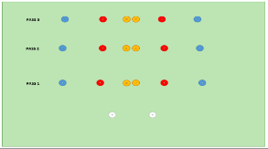  - 2 attackers on white cones  - Coloured cones in a straight horizontal line & colour indicates length of pass, ie, red-pop, Yellow- normal, green – wide.  - Coach calls colour sequence eg. yellow, blue, red  - First player runs out to give pass from coloured cone to receiver and complete sequence.
Game  (15 Minutes)  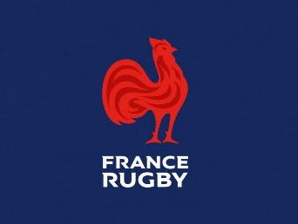 | France Game  - 4 v 4  - 20 x 20 grid  - Attack has 5 phases to score  - Once touched defender must retreat off pitch before then can come back into the game.  - Attackers to try and make use of space created.

