Mini 1- Week 1
Sample Session Theme: Return to Rugby
Session Focus – Ball Familiarisation

ACTIVITY | NOTES
Warm Up Game with Movement Skills  (10 Minutes) | Movement Skills:  - Number Freeze plus animal movements  - Stuck in the Mud  Warm Up Game:  - Bugs and Spiders 5x5 grid and 10x10m grid
Game  (10 minutes) | Any Direction Touch  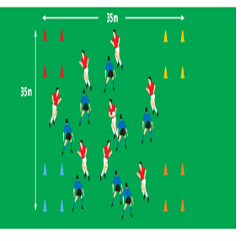  - 4v4  - Run and pass in any direction  - Play until a mistake is made or after 5 touches  - Pass within 3 secs  - Score with 4 coloured zones
SKILL DEVELOPMENT  Catch & Pass  (10 minutes) | Keep Ball  - 10 x 10m grid  - 5 v 5  - Aim to get 3 passes without interception  - Pass in any direction but cannot move with ball  - If intercepted or ball hits ground turnover  - 1 point for 3 completed passes, reset same team.  Passing Races  - 1 Player start on red x facing each other  - One ball per group, coach calls sequence, eg green, blue, yellow.  - Player must move to colours and complete one pass  - Set up other groups and build in time or races.
Game  (15 Minutes) | Fiji Game  - 4 v 4  - 20 x 20m grid  - Attack has 5 touches to score on 6th touch turnover.

