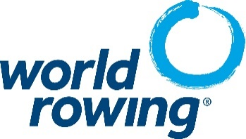

World Rowing Commission Nomination Form 2023

Our member national federation, __________________________________________________ (name of federation), would like to make a nomination for the following World Rowing Commission:

Coastal Rowing Commission
Equipment & Technology Commission
Indoor Rowing Commission
Sports Medicine Commission
Youth Rowing Commission

Information on the candidate:

First and Last name:

Gender: Male, Female Birthdate: _______________

Nationality: _________________ Email address: __________________________________________

Education History:

Professional History:

Sport History:

Name and Signature of Federation President or Secretary General:

______________________________________________________________________________

Please submit this completed Nomination form to World Rowing by 20 October 2023
World Rowing
Av. De Rhodanie 54, 1007 Lausanne, Switzerland
Fax +41-21-617 83 75 or Email: info@worldrowing.com

World Rowing Commission Nomination Form 2023

Integrity Check Form
(to be completed by the candidate)

- Have you ever been convicted of any criminal offence in any country? *

Yes No

*Please provide details of the nature of the offence, penalty, sentence or order of the court and date and place of court hearing (as an attachment to this nomination form)

- Are there any charges against you yet to be heard, or are you aware of any current police investigation, in any country involving you? *

Yes No

*Please provide details (as an attachment to this nomination form)

- Have you ever been removed from any board (whether of a sports organisation or otherwise), had disciplinary action for misconduct taken against you (whether by an employer or otherwise), or had any adverse finding against you, following any investigation, in your capacity as a shareholder, director, trustee, or any other voluntary position? *
Yes No

*Please provide details (as an attachment to this nomination form)

I confirm that the information provided above is complete and accurate, to the best of my knowledge. I am fully aware that I am subject to the World Rowing Code of Ethics and other World Rowing rules and regulations, and I abide fully by these rules.

Place, date: ________________________________________

Name (first name and family name): ________________________________________

Signature: ________________________________________

World Rowing will keep this form on file as long as necessary and treat it as confidential

Please submit this completed Nomination form to World Rowing by 20 October 2023
World Rowing
Av. De Rhodanie 54, 1007 Lausanne, Switzerland
Fax +41-21-617 83 75 or Email: info@worldrowing.com

